Slack features:

* Set reminders
* Pin documents
* Nikabot (gant chart)
* Polls
* ideabot

Note: ill talk about each of these, if you want to put them on one slide or put one on each separate slide it doesn’t bother me.

Just pictures you can insert into the presentation:

Set reminders feature:

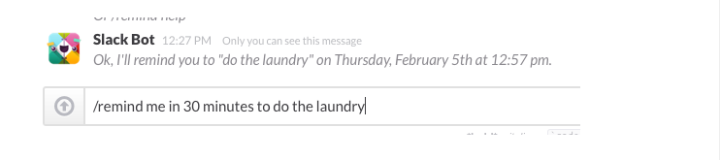

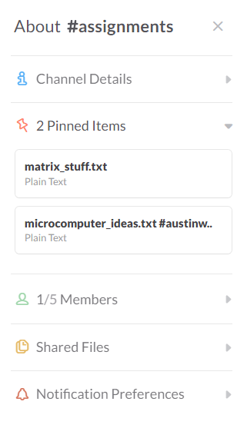

Idea bot- list out ideas anytime you want, it stores them and team members can up vote or commented on.

Problem Statement:

To build an automated clock/ display which can be updated via a mobile or online application, using a display that we build or buy. The application must be secure so that no one can tamper with the output of the display. The display will be controlled by a microcontroller that will save all the displays information in case of power outages and must last at least one year. Also the display should be able to present messages that the faculty deems necessary.